November 1, 2022

Dear Certification and Licensure Exam Fee Reimbursement (CLEFR) Program Participant:

The Office of the State Comptroller (OSC) and the Internal Revenue Service (IRS) have determined that reimbursements under the CLEFR Program do not qualify for the exclusion from gross income that applies to benefits payable under educational assistance programs. Therefore, these reimbursements will be reported as taxable income.

The Office of Employee Relations (OER) has provided OSC with information on all reimbursements you received through the CLEFR Program in calendar year 2022. OSC will levy the taxes over one paycheck in the 2022 calendar year. The exact pay date is November 23, 2022 for the Administrative cycle and December 1, 2022 for the Institutional cycle.

OER is not able to answer questions about your specific tax situation. A tax professional or the IRS must address questions regarding your specific tax situation including whether you may be eligible to claim a deduction on your personal income tax. The IRS website is www.irs.gov. You may also contact the IRS directly at 1-800-829-1040.

If you have questions regarding the CLEFR Program, please email psttraining@oer.ny.gov.

Sincerely,
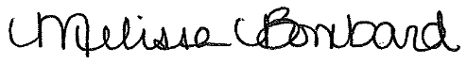

Melissa Bombard
Employee Relations Associate

